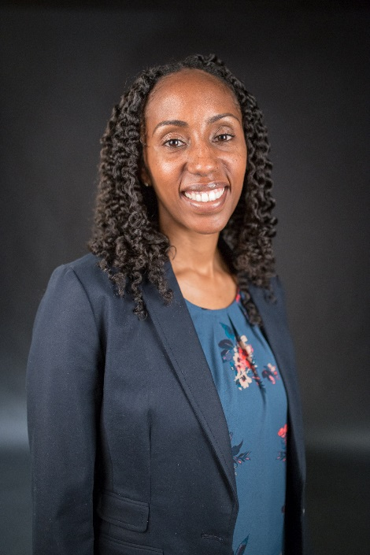

Kimberly M. Lowry, Ph.D. currently serves as the Associate Vice Chancellor of Student Engagement and Success at Houston Community College. Dr. Lowry’s professional background includes administrative experiences across various functional areas including Advising, Dual Credit, Veteran Services, Registrar, Disability Services, TRIO programs and Enrollment Management. Prior to this role, she served as the Associate Vice President of Academic Affairs and Student Success, the Executive Dean of Student and Enrollment Services and the Director of Advising and Assessment at Eastfield College. During her time at Eastfield College, she was responsible for all aspects of Student Services and launched the College’s first strategic enrollment management plan. She has years of higher education experience, spanning across various institutional types which include Wilberforce University, The University of North Texas at Dallas and Eastfield College.
As a college student, Dr. Lowry attended and graduated from Antelope Valley Community College and then transferred to California State Long Beach where she earned both her M.S. in Counseling with an emphasis on Student Development in Higher Education and her B.A. in Psychology. Dr. Lowry then received her Ph.D. in Higher Education at the University of North Texas. Her research focuses on community college choice, high achieving African American students and student athletes. Finally, Dr. Lowry stays involved in numerous professional associations and serves as the Director of the Community College Division for NASPA as well as a board member for the National Council for Instructional Administrators.

